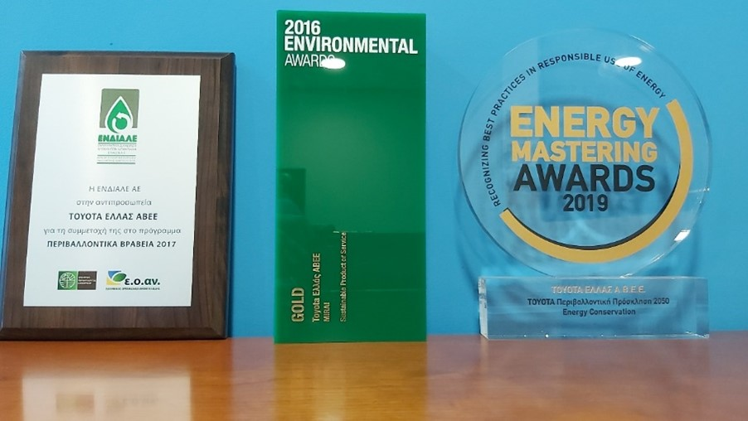
The company which is responsible for the Alternative Management of Waste Lubricating Oils titled "ENDIALE" has awarded TOYOTA Hellas for the best alternative management of waste lubricating oils, their collection and delivery for recycling.
"Boussias Communications" has awarded Toyota Hellas at the Environmental Awards 2016 with a gold award in the category "Sustainable Product of Service" for the company’s Environmental Policy and its Local Actions. The company has been also awarded at the Energy Mastering Awards 2019 with a gold award in the category "Energy Conservation" for the integrated energy saving programme titled “Toyota Environmental Challenge 2050”, the implementation of relevant CSR actions and the improvement of environmental management results through staff training. Finally, the company has received the bronze award in the "Leadership" category for the effective response of Toyota Hellas and its Network of Authorized Dealers and Repairers to the Toyota Environmental Challenge 2050.
